

Bar Code Medication Administration (BCMA)  
BCMA Backup System (BCBU)  
InterSystems Caché Installation Setup

Version 3.0

April 2016

Department of Veterans Affairs (VA)

Office of Information and Technology (OIT)

Product Development (PD)

Revision History

| Date | Revision | Description | Author |
| --- | --- | --- | --- |
| 04/2016 | PSB*3*91 | Document update for installation of Cache version 2014. | Kevin Cownie |
| 04/2015 | PSB*3*84 | Document updated by Kevin Cownie. Entire document reformatted. | Kevin Cownie |
| 07/2011 | PSB*3*65 | Footers updated; removed HSITES and added Product Development, removed VistA. Renamed instances of CACHE to Caché throughout the document. Updated version to reflect BCMA v3.0 version. |  |
| 08/2003 | PSB*2*17 | Original Released Bar Code Medication Administration Backup System (BCBU) InterSystems Caché Workstation Installation Setup Guide. |  |

Contents

1 InterSystems Caché Installation Setup 1

1.1 Caché Configuration Manager 6

1.1.1 Adding a Database 7

1.1.2 Adding a Namespace 12

1.1.3 Global and Routine Mapping 16

1.1.4 Global Mapping 17

1.1.5 Routine Mapping 19

1.1.6 Cache Licenses install 21

1.1.7 Removing Read/Archive Properties 22

1.2 Telnet Instructions 22

1.3 Setting up Telnet and Terminal Users 34

1.4 Setting up the BCMA Shortcut 40

1.4.1 Edit a TRM or VTRM device 45

# InterSystems Caché Installation Setup

This section illustrates step-by-step installation of Caché v2014, for use with Bar Code Medication Administration Backup System (BCBU) Workstation.

The Caché software was downloaded from the VA FTP sites and is located under the corresponding version of the CACHE folder. To start the setup locate the downloaded executable and run it.

Accept the license agreement and click **Next.**

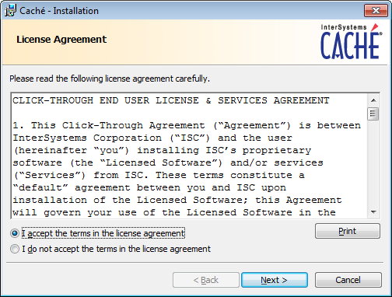

Figure

Click **NEXT** at the Define Cache Instance Name.



Figure

Click **Next** at Destination Folder.

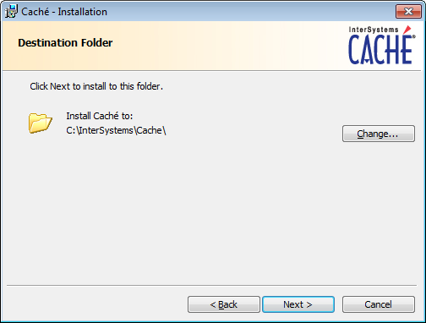

Figure

Choose **Development** and click **Next**.

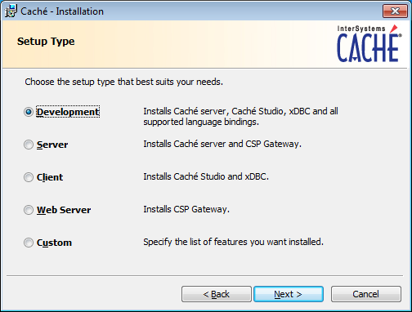

Figure

Continue following the instructions and accept the defaults for your system.

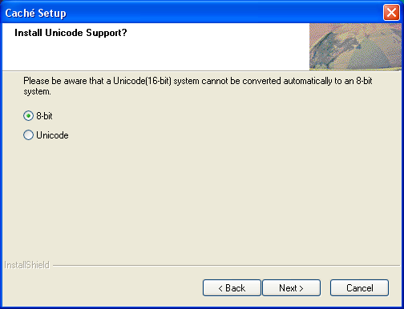

Figure

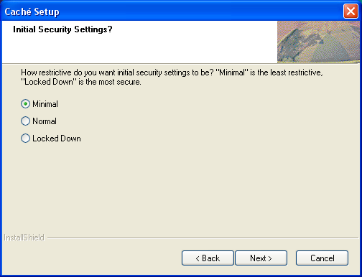

Figure

Click **Install**.

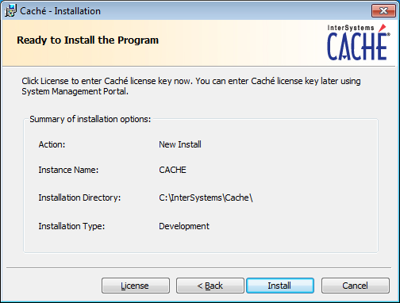

Figure

Uncheck **Display the Getting Started page** and click **Finish**.

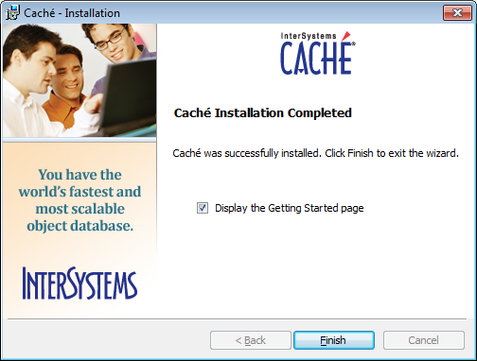

Figure

Upon the completion of a successful installation, a "Blue Cube" will appear on the PC toolbar in the lower right hand side of the screen.

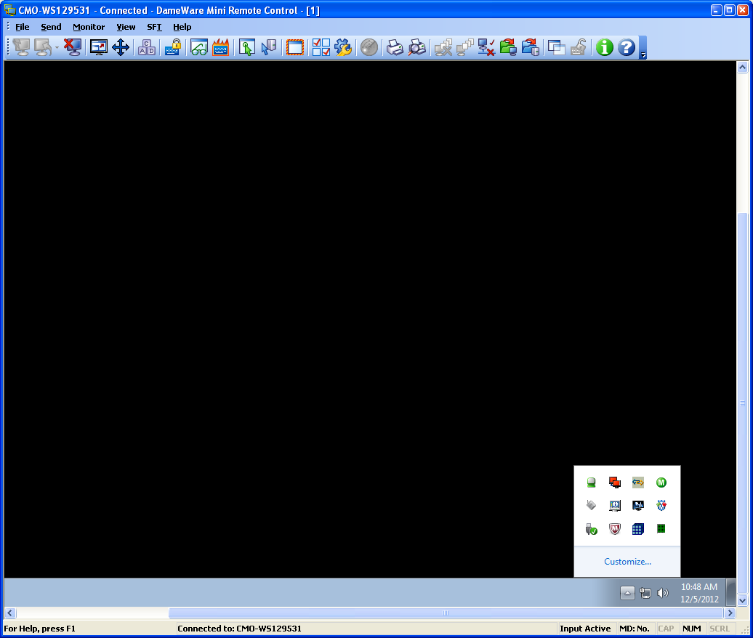

Figure

## Caché Configuration Manager

Caché must be configured with databases, namespaces, and routines by using the Management Portal located on the Caché cube menu options.

Right clicking on the cube will display the menu options for Caché, and then choose **Management Portal**.

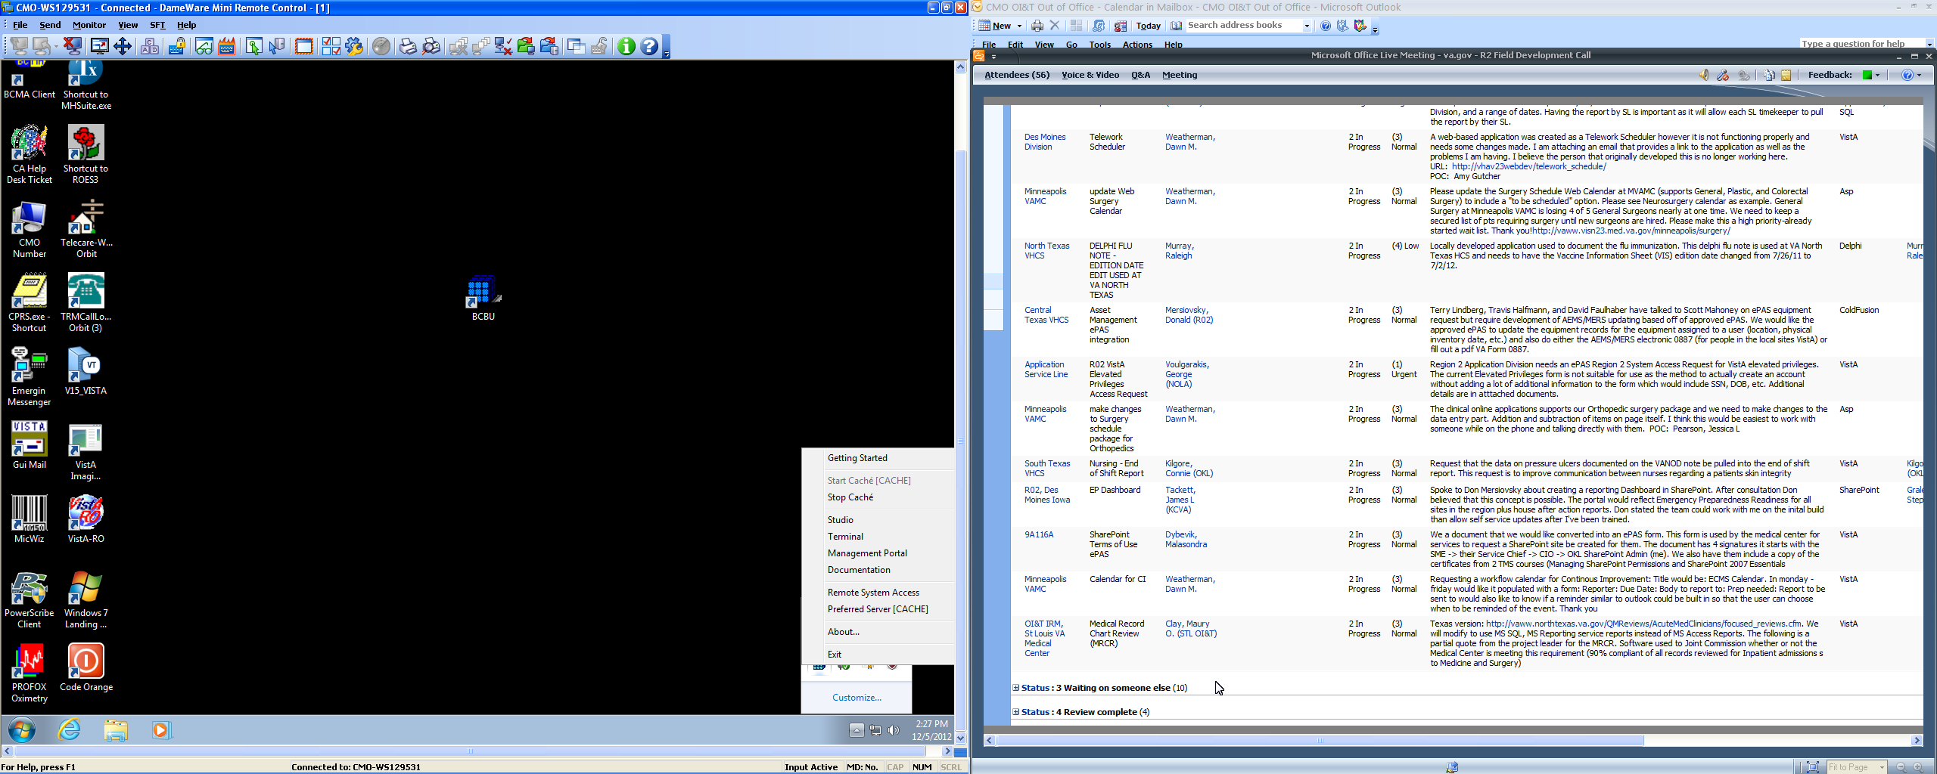

Figure

### Adding a Database

The first step is to add a Database. From the Main Screen, choose the **Menu** button and then **Configure Databases**.

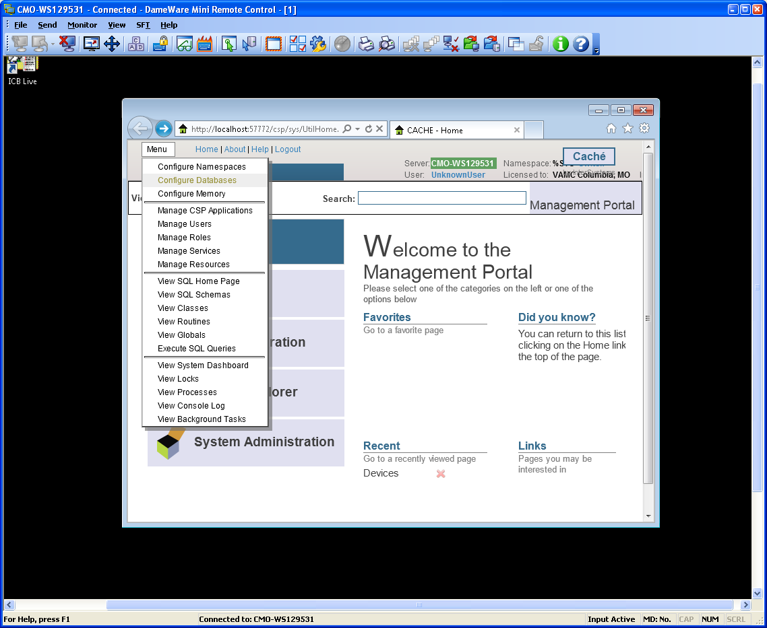

Figure

Select the **Local Database** option and then **Create New Database** button.

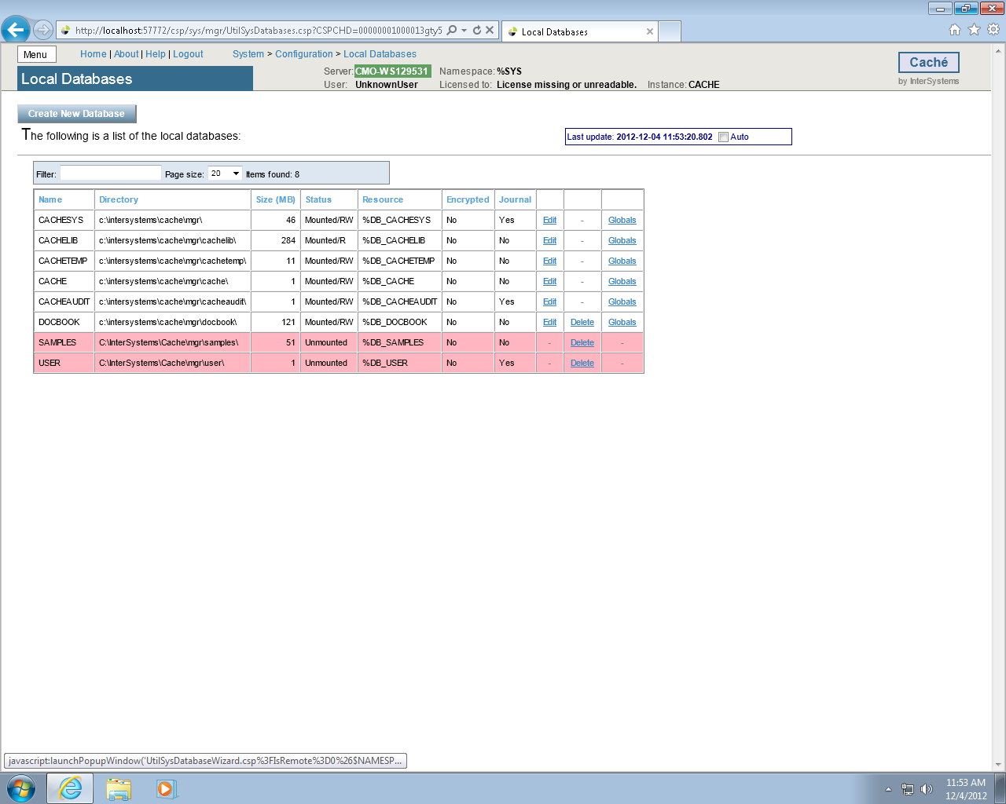

Figure

Type **VISTA** as the name of the database and enter **C:\BCMABU** into the Directory Selected field. Click **NEXT** to continue.

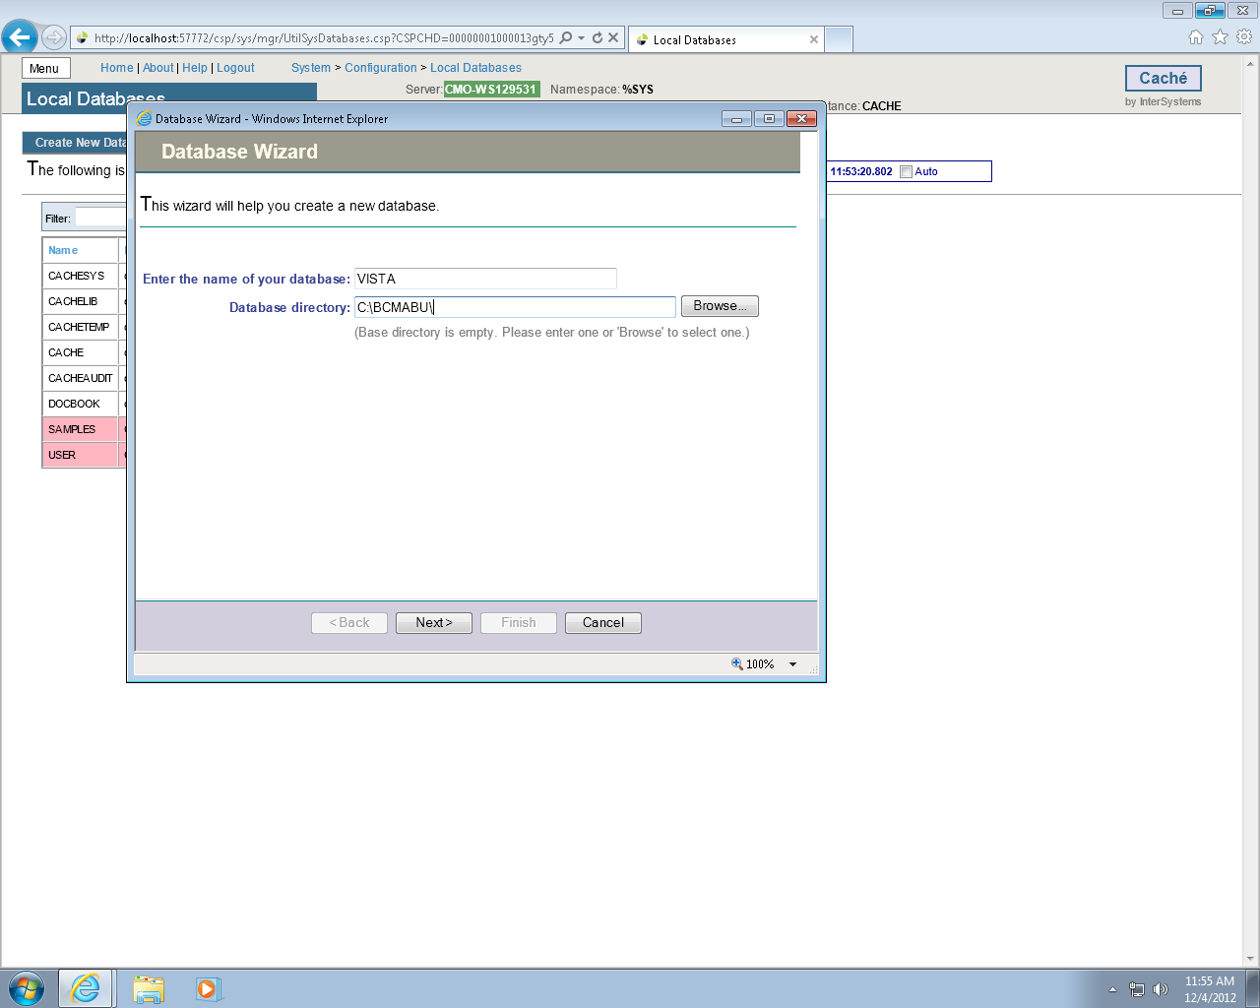

Figure

Verify values entered and click **FINISH**.

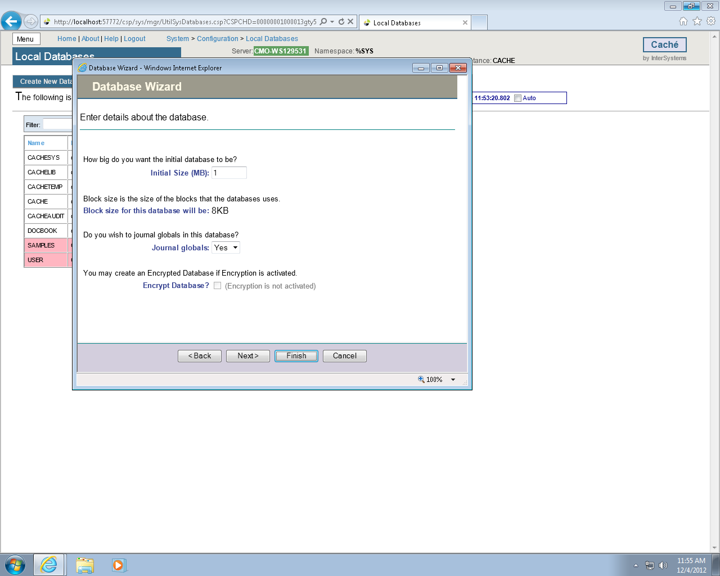

Figure

The newly created database should now appear in the list (bottom of the list) with C:\BCMABU\ as its directory.

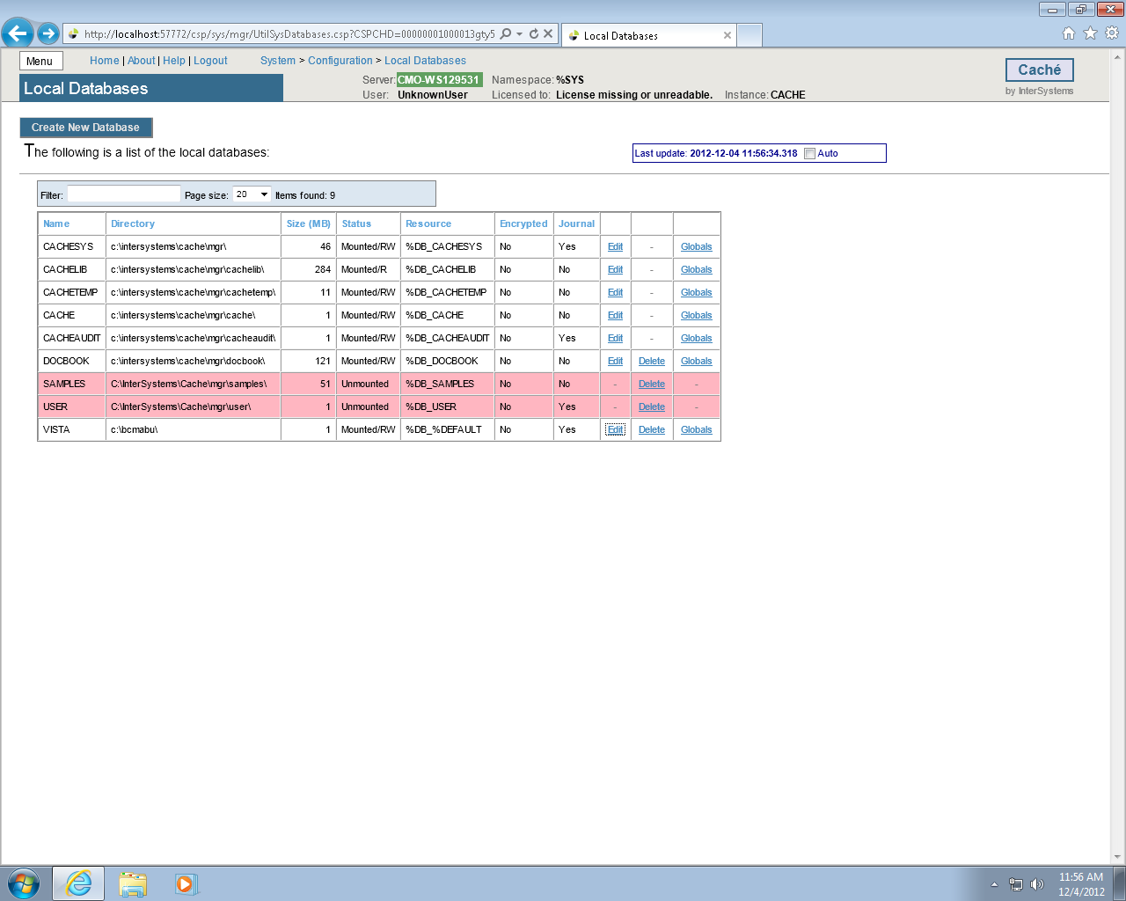

Figure

### Adding a Namespace

We will create the namespace VISTA and attach it to the VISTA database.

Click the **MENU** button and choose **Configure Namespaces**.

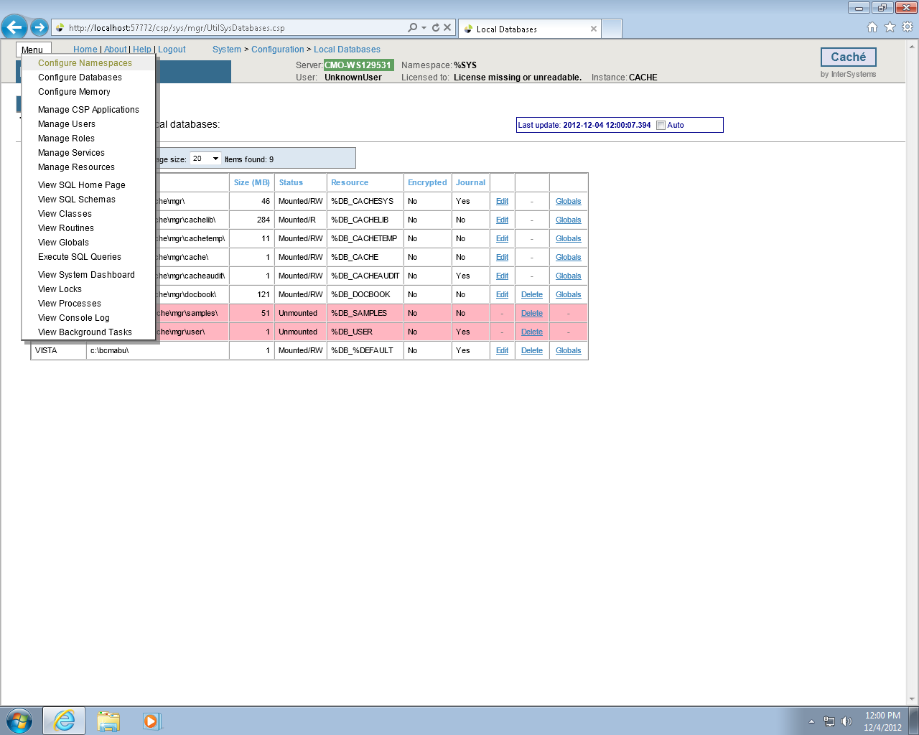

Figure

Click Create **New Namespace** button.

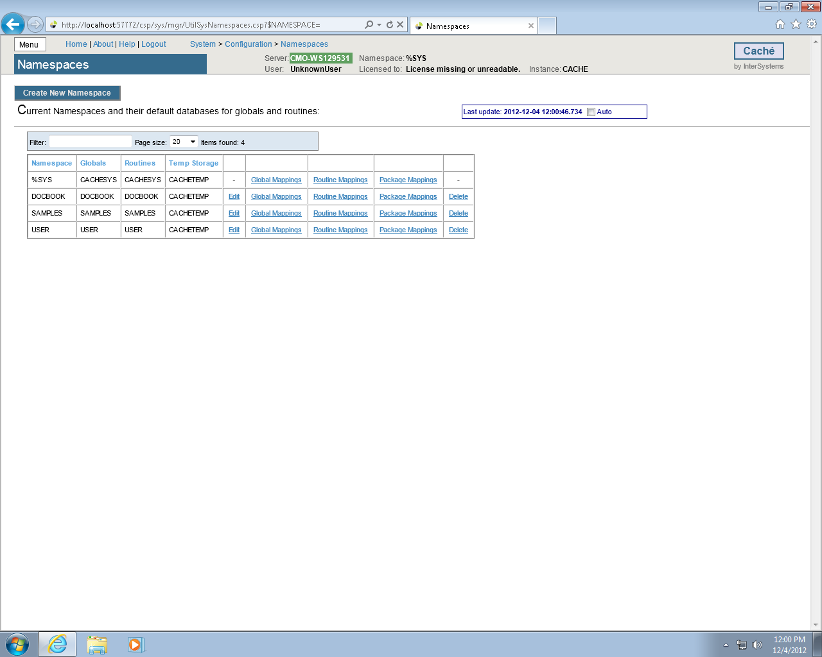

Figure

Type **VISTA** as the namespace and select **VISTA – C\BCMABU\** as the existing database. Click **Save**.

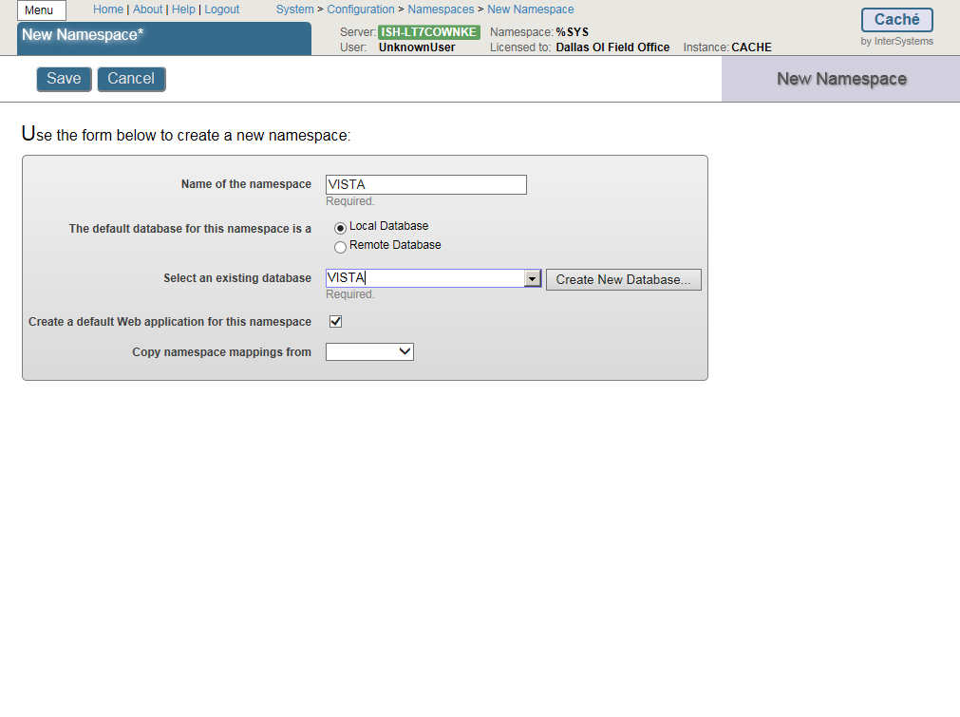

Figure

VISTA namespace should be seen in the listing of Caché Namespaces.

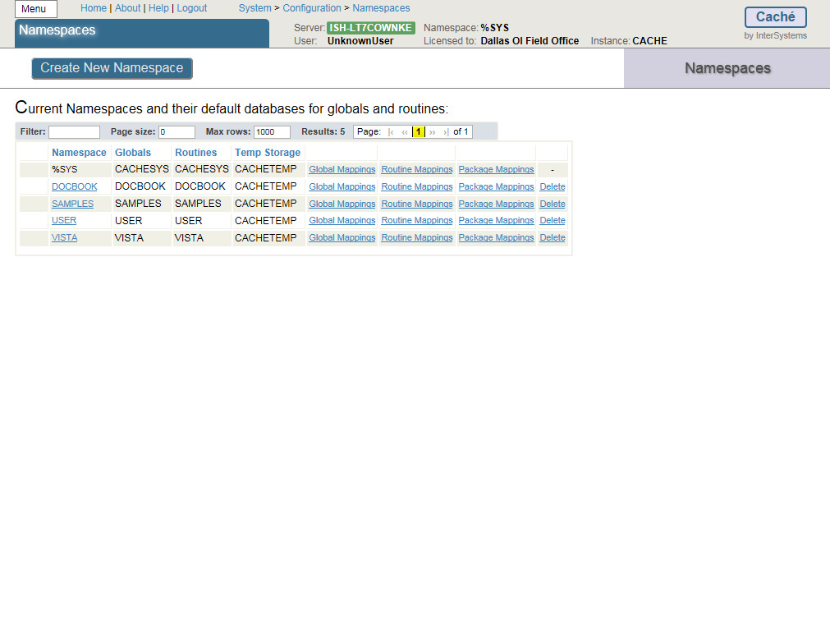

Figure

### Global and Routine Mapping

Global and Routine Mappings are created under the Configuration Namespaces option by selecting Global Mappings and Routine Mappings for the VISTA namespace.

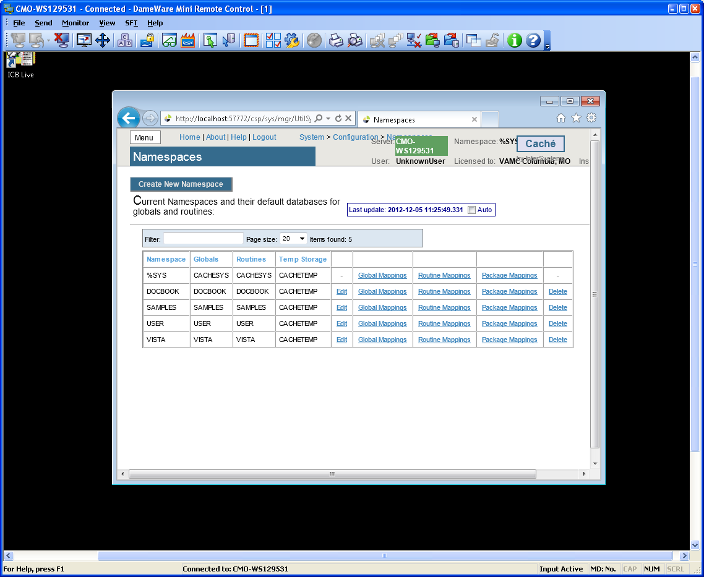

Figure

### Global Mapping

Click Global Mappings for the **VISTA** namespace. Then click **New** to create the global mapping definition as shown in the following slide.

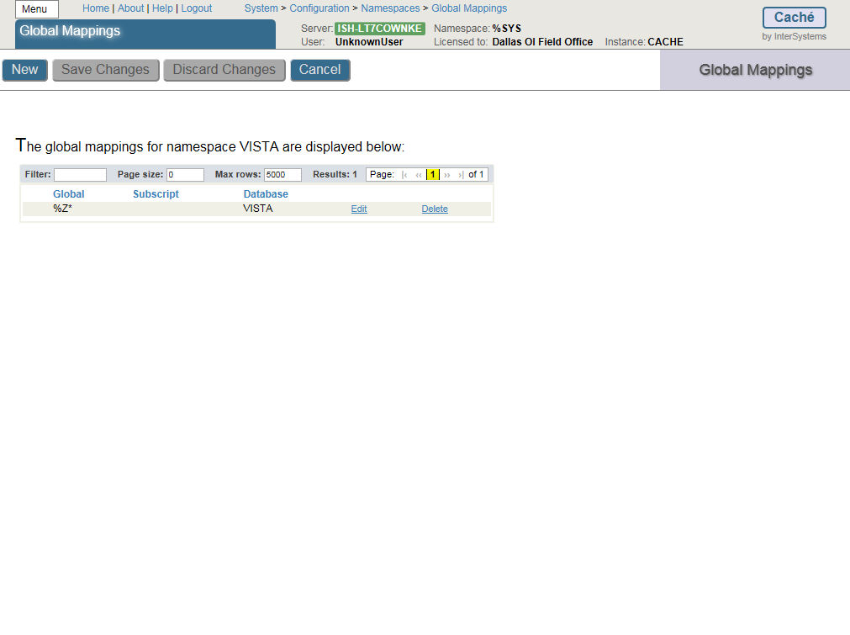

Figure

The Global Database Location is **VISTA** and the Global name is **%Z*.** Click **Apply** (Figure 22)and **Save Changes**.

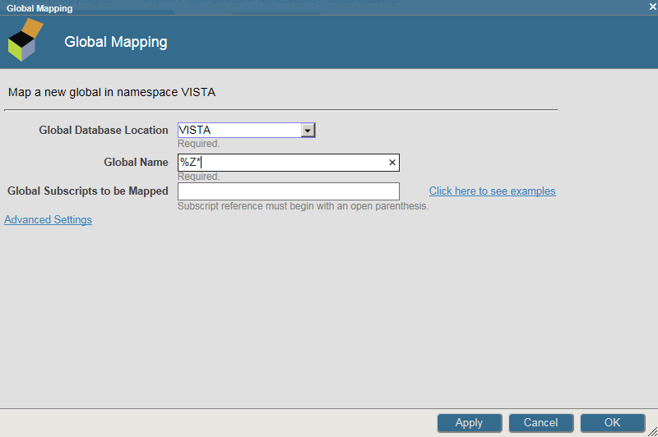

Figure

### Routine Mapping

Click the **Menu** button (Figure 23) and then **Configure Namespaces**.

Select Routine Mapping.

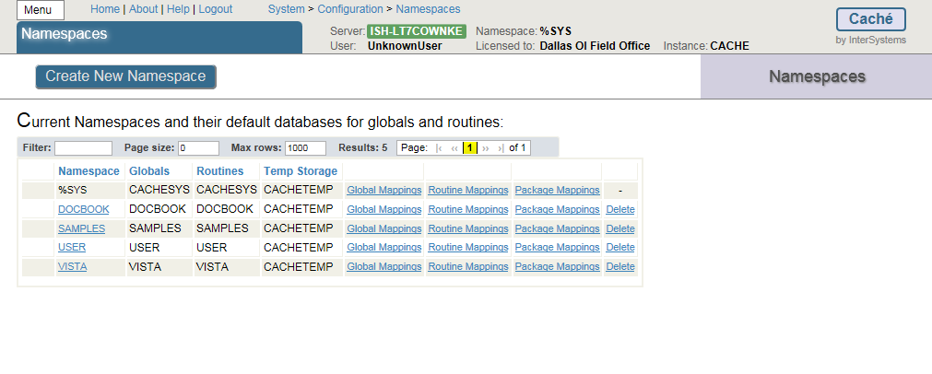

Figure

Select **New Routine Mapping**. Type the first routine name, **%DT*,** (Figure 24) in the space provided and select **VISTA** as the routine database location. Click **Apply**. Repeat this procedure for routine names %**RCR, %XU* and %Z*.** When complete, your routine mapping should appear as shown in Figure 25. Click **Save Changes** and close this window.

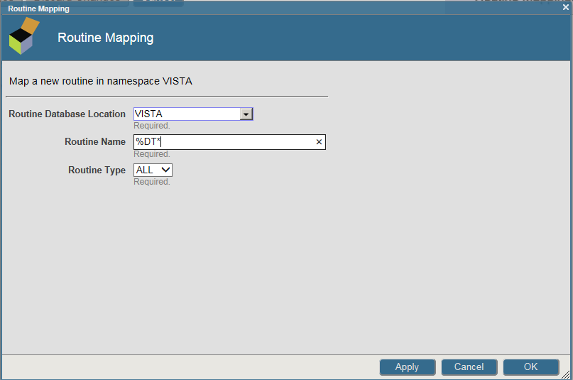

Figure



Figure

Shut down CACHÉ

Click the Blue Cube (PC toolbar in the lower right hand side of the screen) and choose Stop Cache.

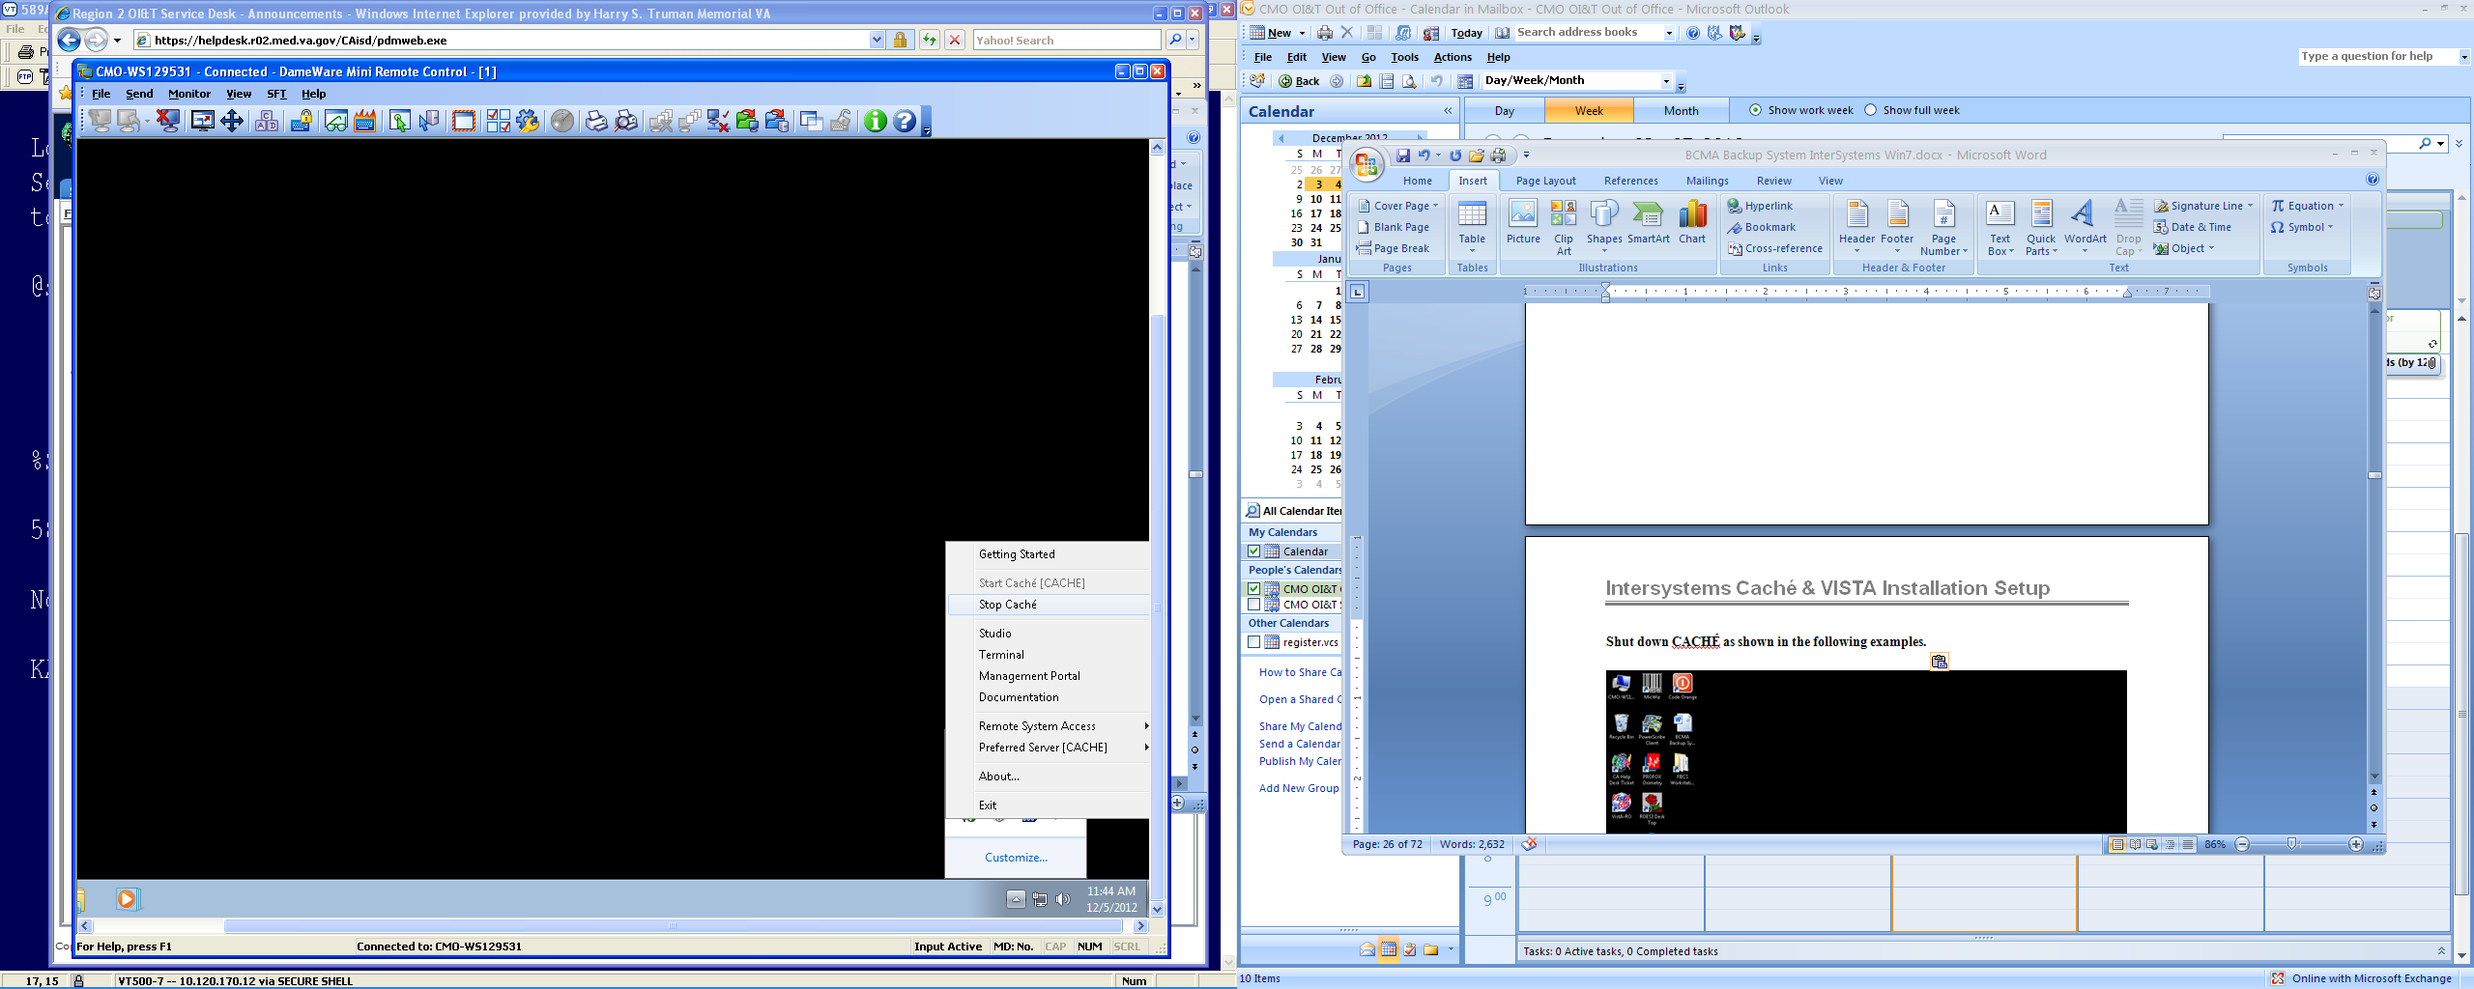

Figure

You will see the following screen as CACHE shuts down.

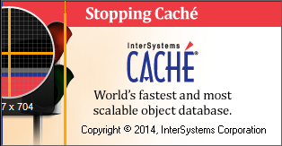

Figure

### Cache Licenses install

The license information is a text file sent to you by InterSystems (cache.key).

Copy and paste into the **C:\InterSystems\Cache\mgr** folder.

CACHE.DAT

Copy the **CACHÉ.DAT** file you downloaded from the VA FTP site and copy it to the **C:\BCMABU** folder.

You may receive a message stating the file is already present and do you want to replace it with the file you are importing. If so, answer **YES**.

### Removing Read/Archive Properties

Using the "Windows Explorer", remove the Read and Archive Properties from the CACHÉ.DAT file. Right click “CACHÉ.DAT” and select "Properties" under the General Tab and Click Advance to remove Archive. Click Apply and then OK.

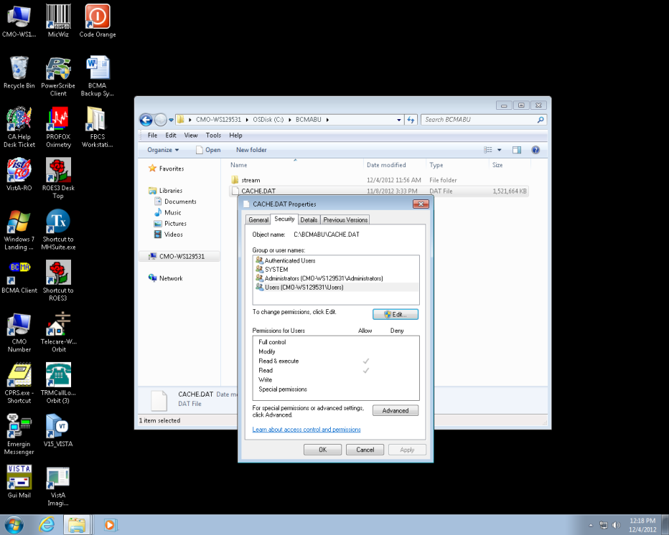

Figure

## Telnet Instructions

Start Caché. Note: The Cache Cube icon is Gray in color at this point, not Blue.

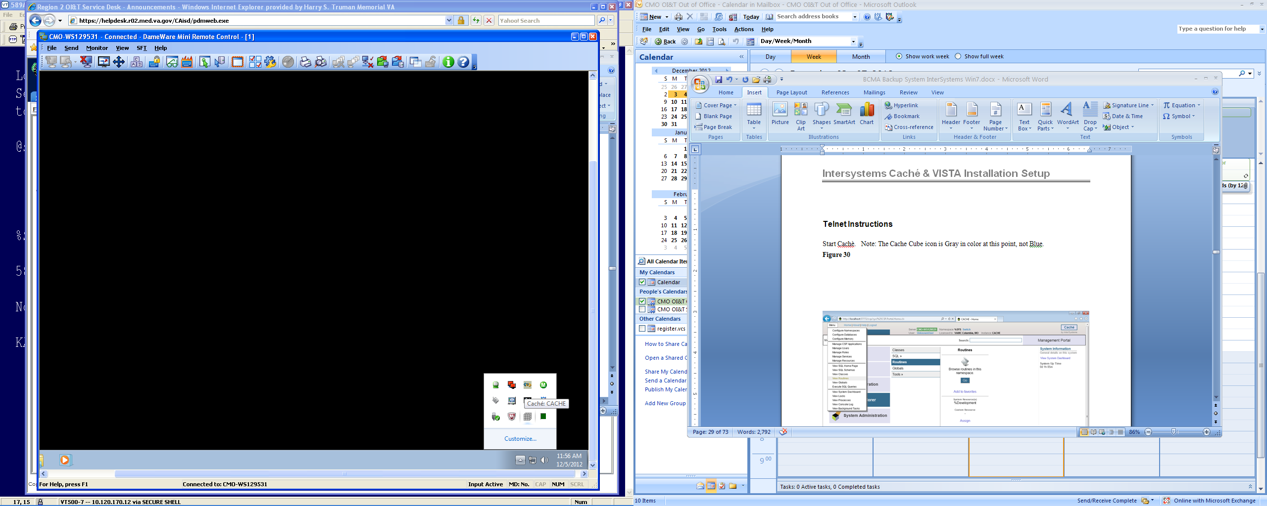

Figure

What we are going to do next is to move the **ZSTU** routine from the **VISTA** namespace to the **%SYS** namespace using the Management Portal.

Select Menu **button** then **View Routines.**

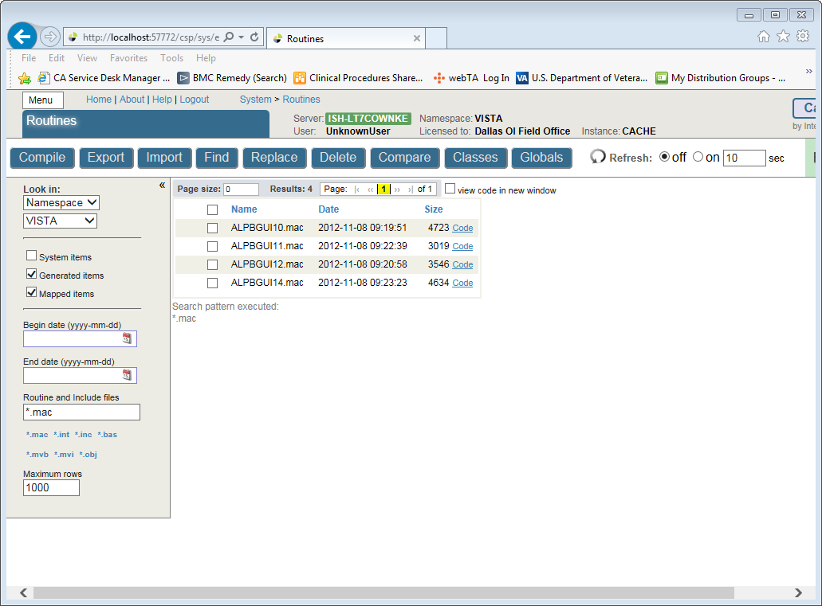

Figure

Select VISTA for the Look in Namespace on the left side of the screen.

Enter ZSTU*.*in the Routines box and click **Export.**

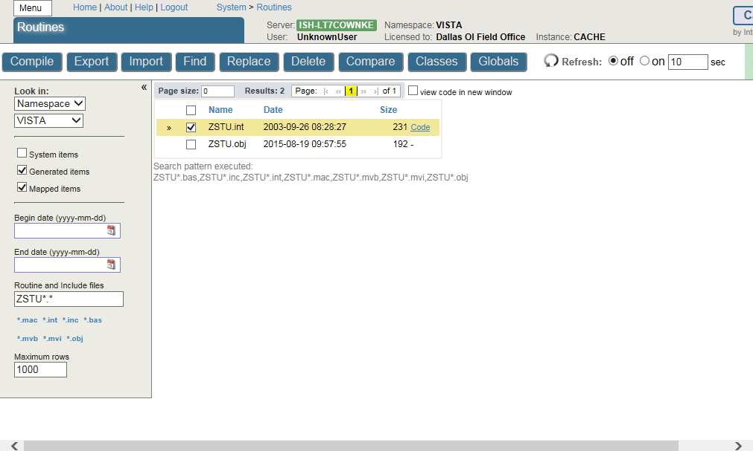

Figure

Make sure the check box is selected for the routine (ZSTU.int).

Click **Export**.

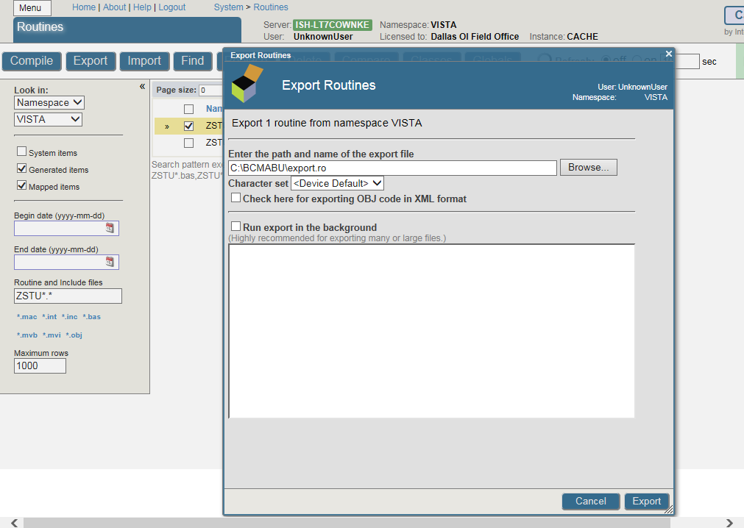

Figure

When finished, a message stating it was completed should appear, click **Done** when complete.

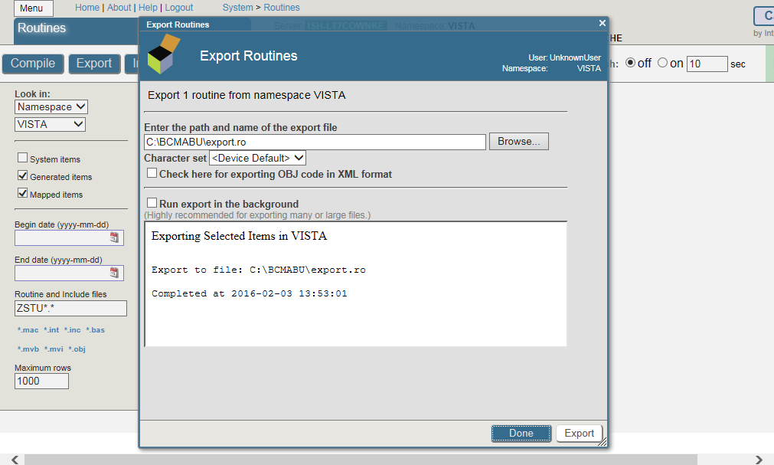

Figure

Click the **Menu button** and then **View Routines**. See steps 1 -6 to accomplish the following: Select the **%SYS** namespace (left side of screen). Select **Import** from across the top. Browse to the path where you exported the routine. Select the routine and click **OK**.

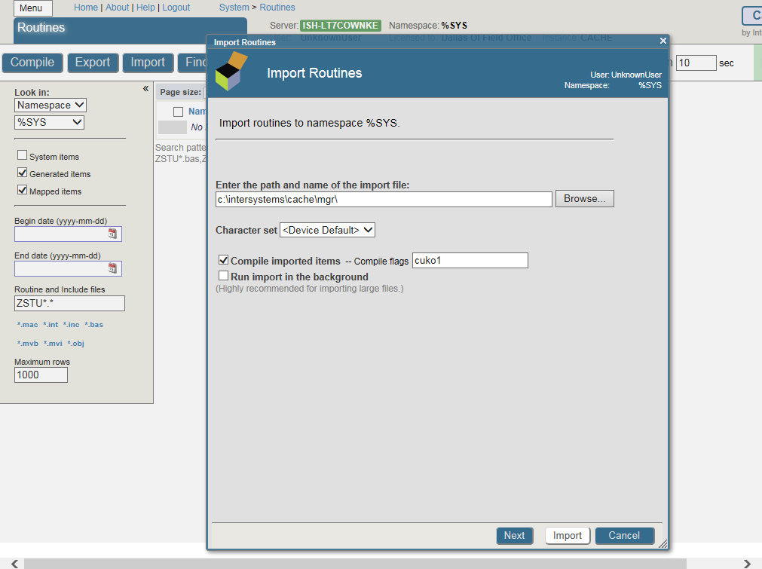

Figure

*Step 1.*

Click the **Browse** button.

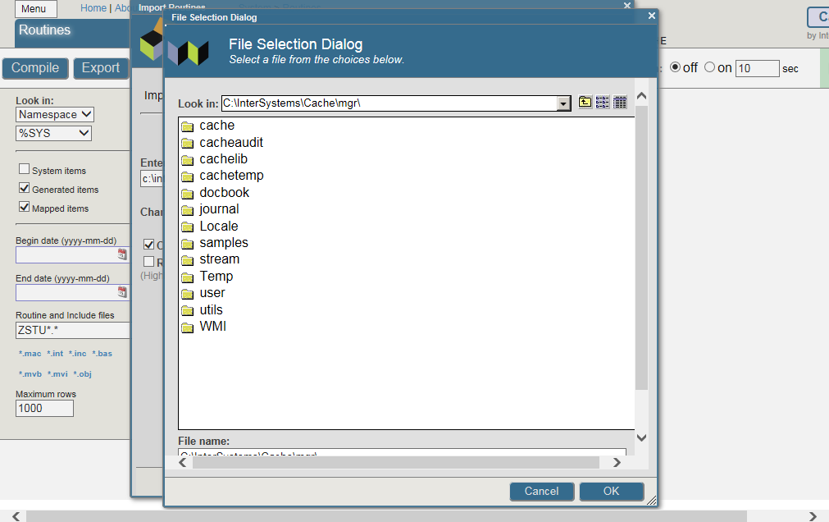

Figure

*Step 2.*

Use the folder icon  on the right to get to the C:

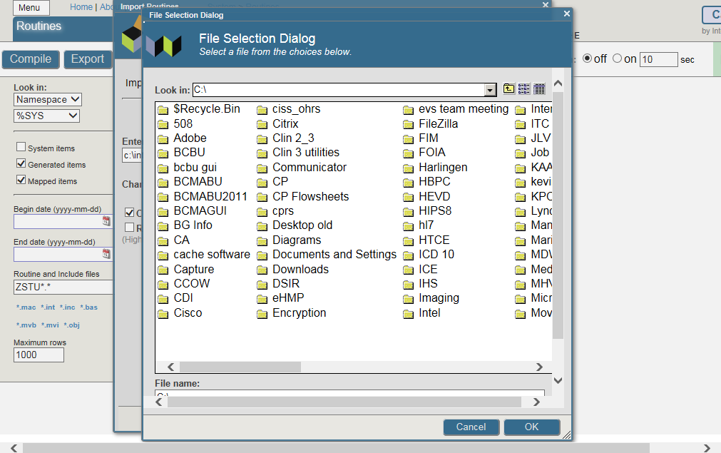

Figure

*Step 3*.

Click **BCMABU**.

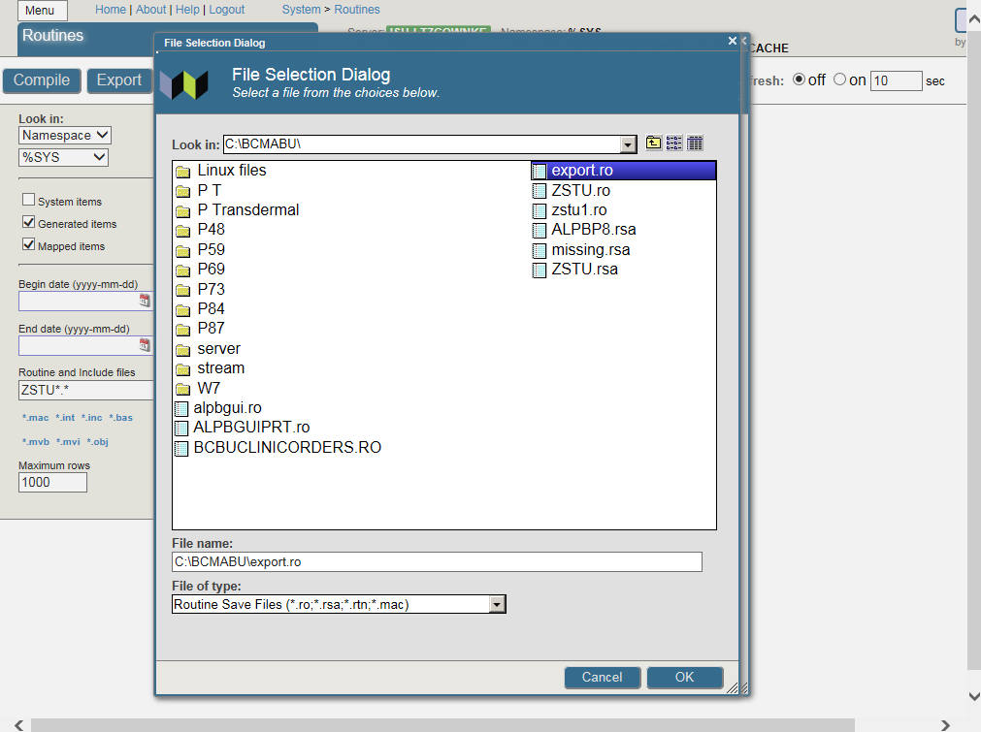

Figure

*Step 4*.

Click **export.ro** and then the **OK** button.

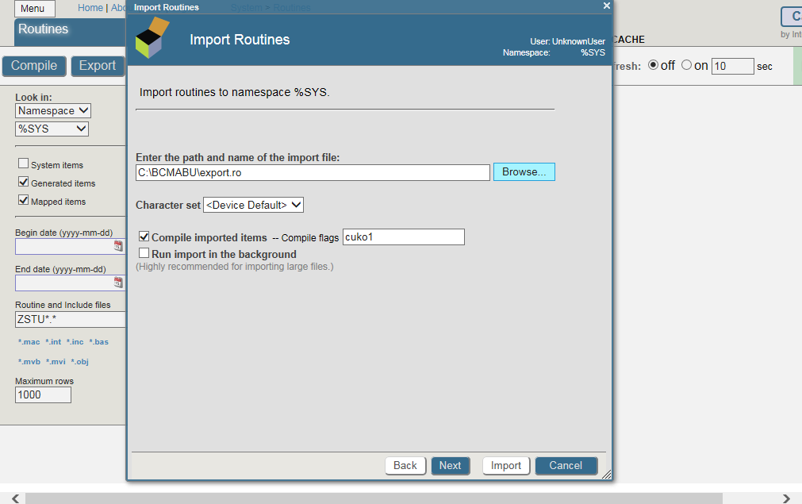

Figure

*Step 5*.

Click the **Next** button.

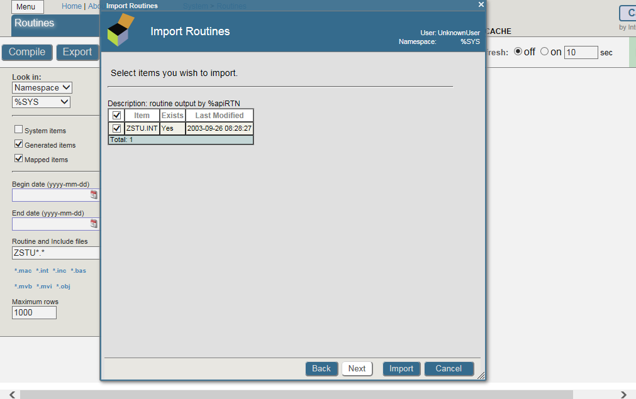

Figure

*Step 6*.

Make sure the box is checked by ZSTU.INT. Click **Import**. The successful completion message should appear as shown in the following screen.

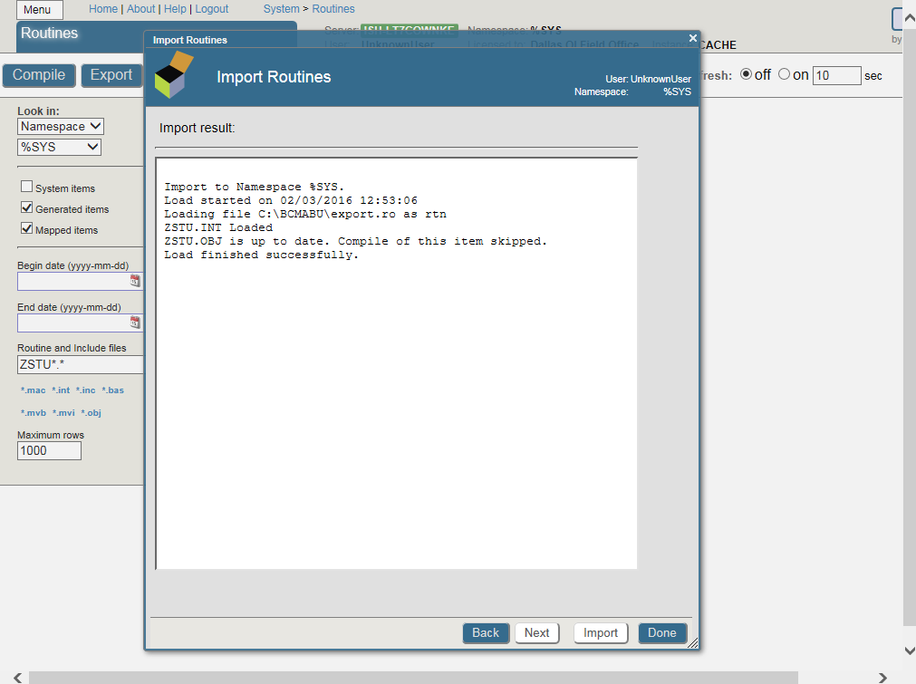

Click Done.

Figure 40

## Setting up Telnet and Terminal Users

We will be using the Management Portal to set up the Unknown User so the Telnet and Terminal Users will connect to the VISTA namespace using the routine ZU.

Click **HOME**.

From the **Menu** button select **Manage Users**. The User Accounts will be displayed.

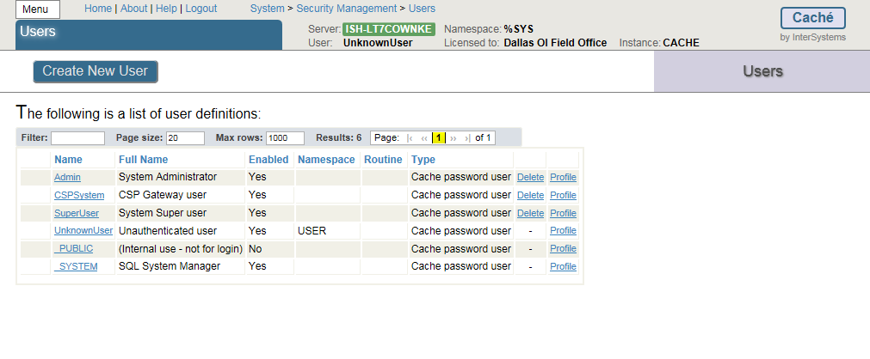

Figure 41

Click on the **UnknownUser** to edit it. Select **VISTA** as the Startup Namespace and enter **^ZU** as the Startup Tag^Routine. Click **Save** then **Close this window.**

(Note: For programmer access, %PMODE in Default Tag^Routine.)

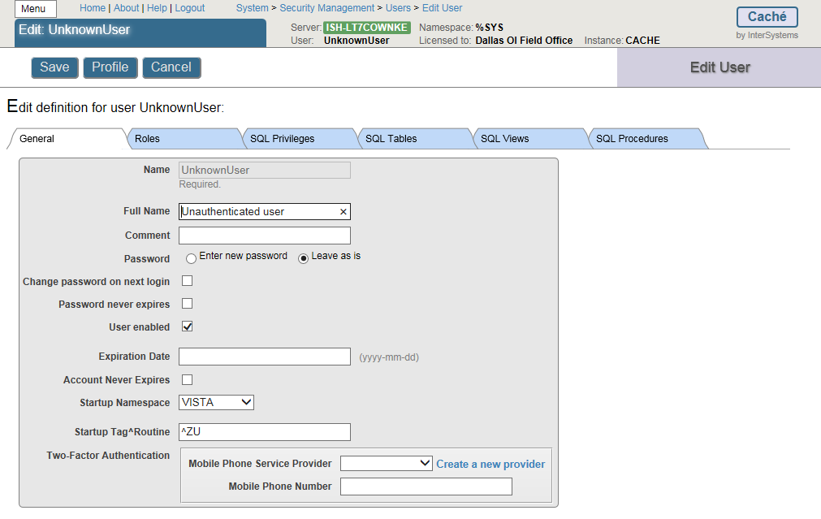

Figure 42

After the edits are done the screen should look like this.

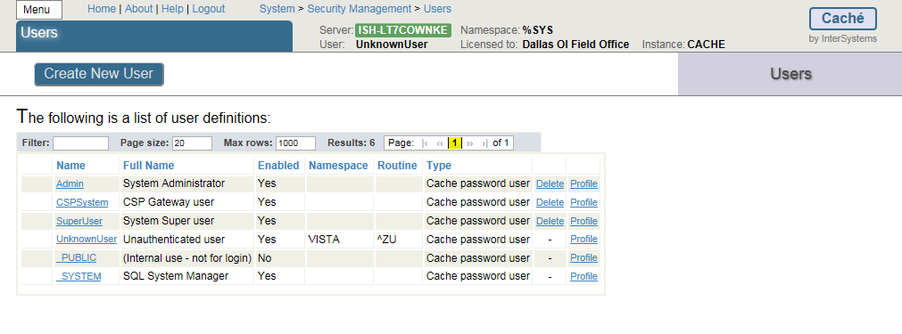

Figure 43

**IMPORTANT NOTE**: Stop and restart Caché. This will be the BCMA Backup Application. The start-up routine **ZSTU** will automatically start up TaskManager.

Verify certain parameters are set for proper operation.

From the Management Portal

Choose **Menu**, and then Manage Services. Click **%Service Telnet (**Figure 45**)** and set **%Service Telnet Enabled = Yes and Public = Yes**.   
If not, click item and change the settings.

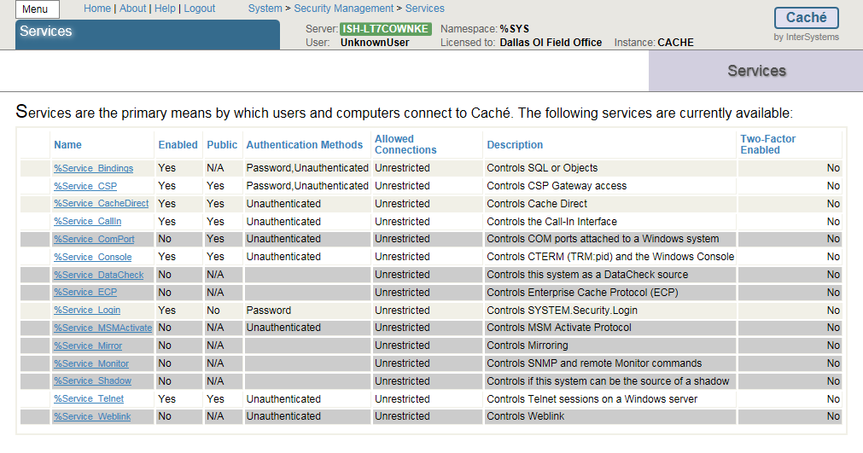

Figure 44

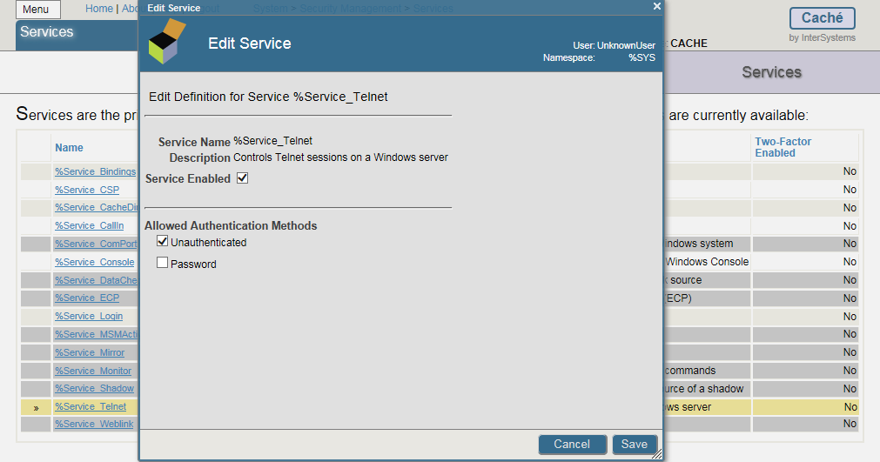

Figure 45

Return to **Home**, select **System Administration** ,then **Configuration** then **Device Settings**, then **Telnet Settings** then **GO** under *View or edit telnet definitions*. Set Telnet **Port** to **19210.** Default setting is 23. (Figures 46-47)

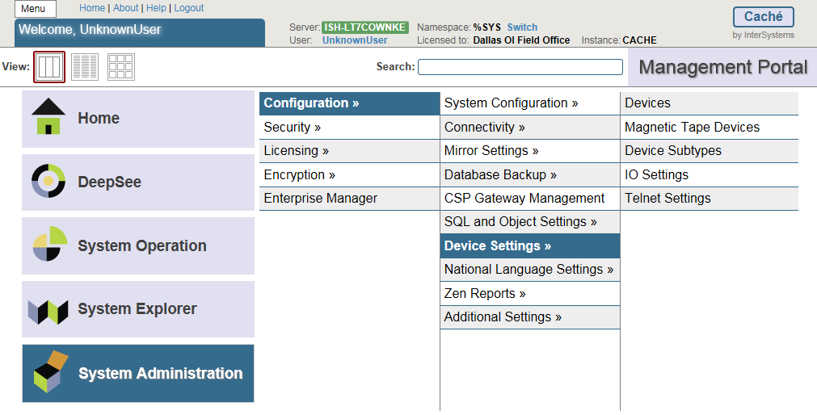

Figure 46

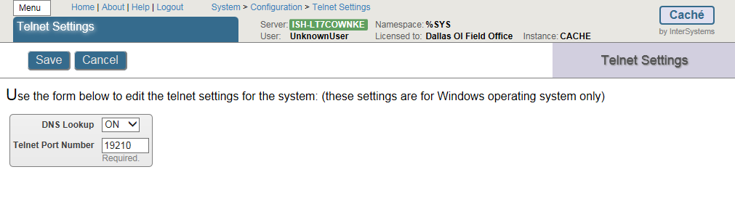

Figure 47

Click **Home**, then **Menu** then **Configure Memory**.

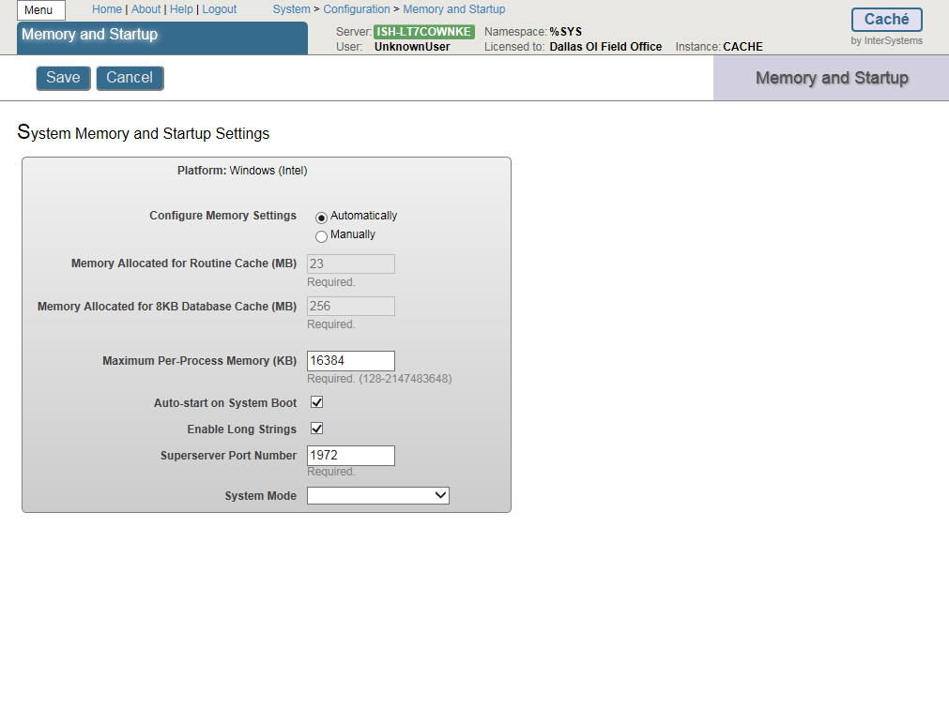

Figure 48

Make sure the “Auto-s*tart on System Boot*” is checked. If not, check it and click **Save**. Close this window.



Figure 49

## Setting up the BCMA Shortcut

To create the shortcut from scratch, right click anywhere on the desktop and select **New/Shortcut**.

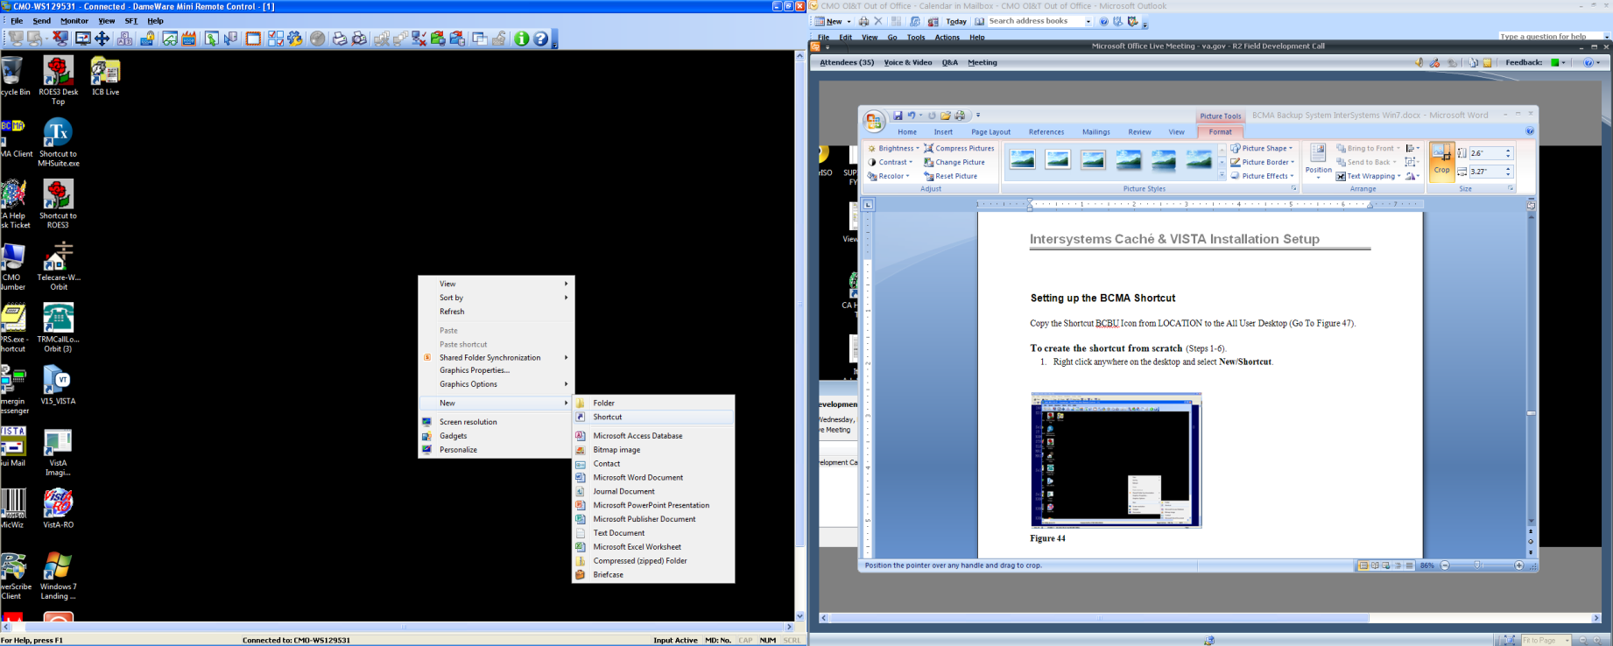

Figure 50

Enter **C:\InterSystems\Cache\bin\css.exe CTERMINAL CACHE** in the *Type the location of the item box.* Click **Next**.

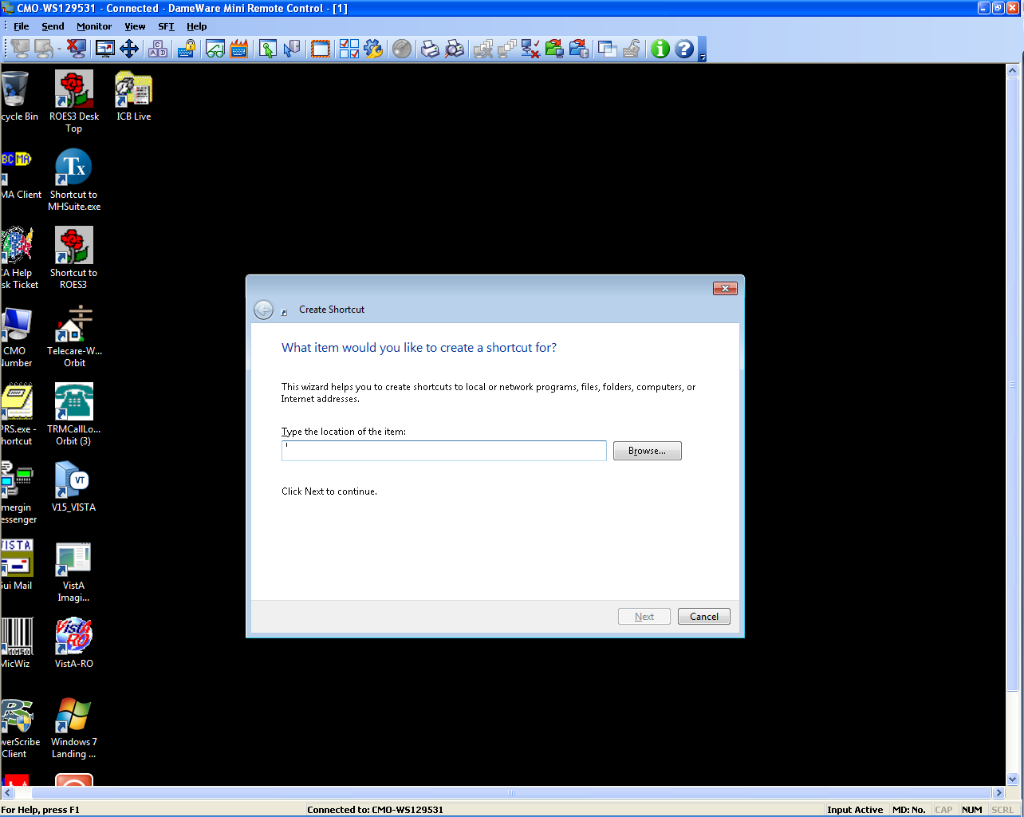

Figure 51

Enter BCBU in the *Type a name for this shortcut* and click Finish (Figure 52).

Copy the Shortcut BCBU Icon to the All User Desktop.

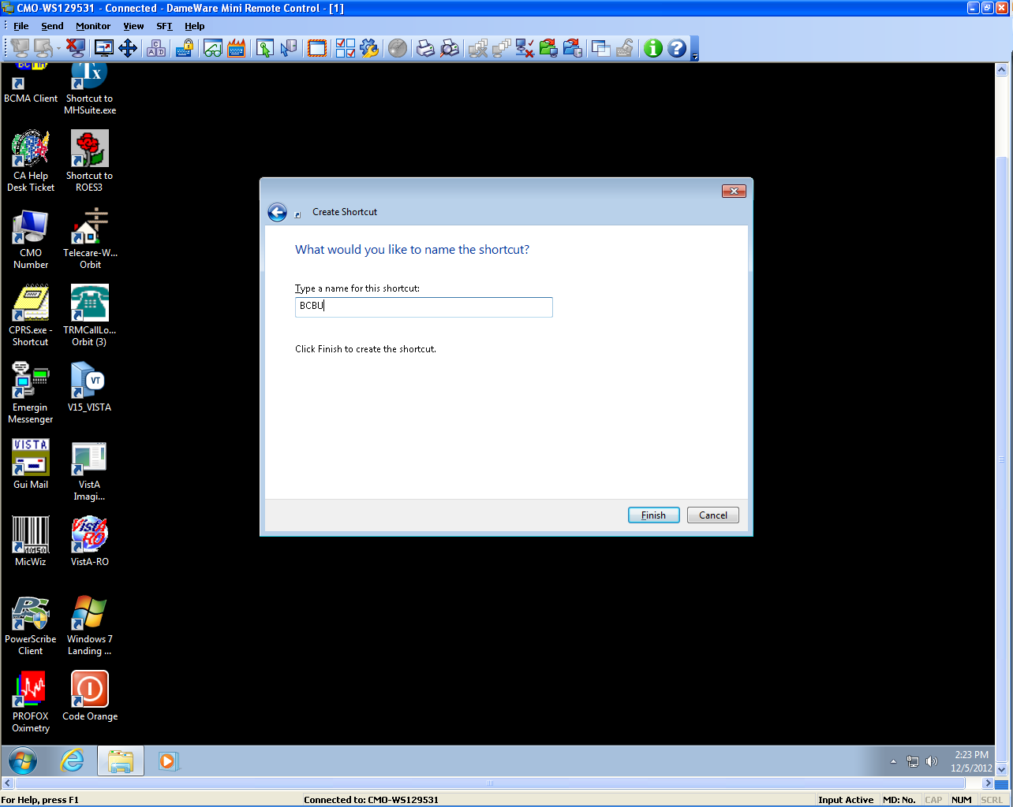

Figure 52

Double-click the BCBU shortcut icon to enter the Backup system on the PC Workstation. Use the appropriate access and verify code to access the system.

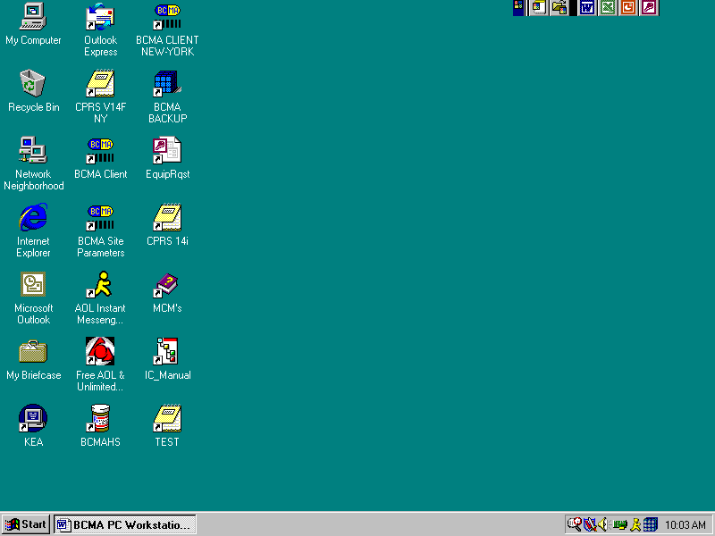

Figure 53

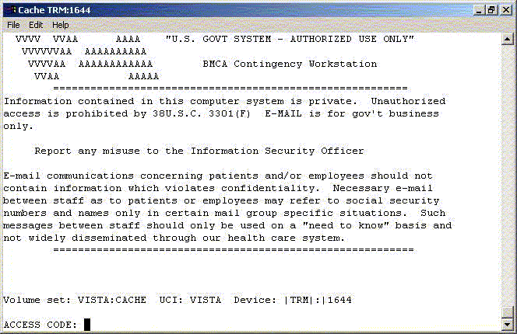

Figure 54

This completes the setup of InterSystems Caché on the BCBU contingency workstation. Refer to the BCBU VistA Install Guide to complete the package setup.

How to Setup the Printer in BCBU PC.

Hook up the printer to the PC.

Install the Window printer drivers.

Click BCBU icon on PC and log in as user that has programmer privileges.

Select Systems Manager Menu Option: *Device Management*

Select Device Management Option: *Device Edit*

Select Device Edit Option: *TRM, TRM, or VTRM Device Edit*

Select Terminal/Printer Device: BCBU

### Edit a TRM or VTRM device

NAME: BCBU PRINTER LOCATION: BCBU WORKSTATION

$I: |PRN| Name of the window’s printer

Example: Window's printer is Lexmark T650 PS3, then enter |PRN| Lexmark T650 PS3

Alt $I:

TYPE: TERMINAL

SUBTYPE: P-HP-P16

SIGN-ON/SYSTEM DEVICE: NO

VOLUME SET(CPU):

ASK DEVICE: NO MARGIN WIDTH:

ASK PARAMETERS: NO PAGE LENGTH:

QUEUING: FORCED SUPPRESS FORM FEED:

Save and Exit.